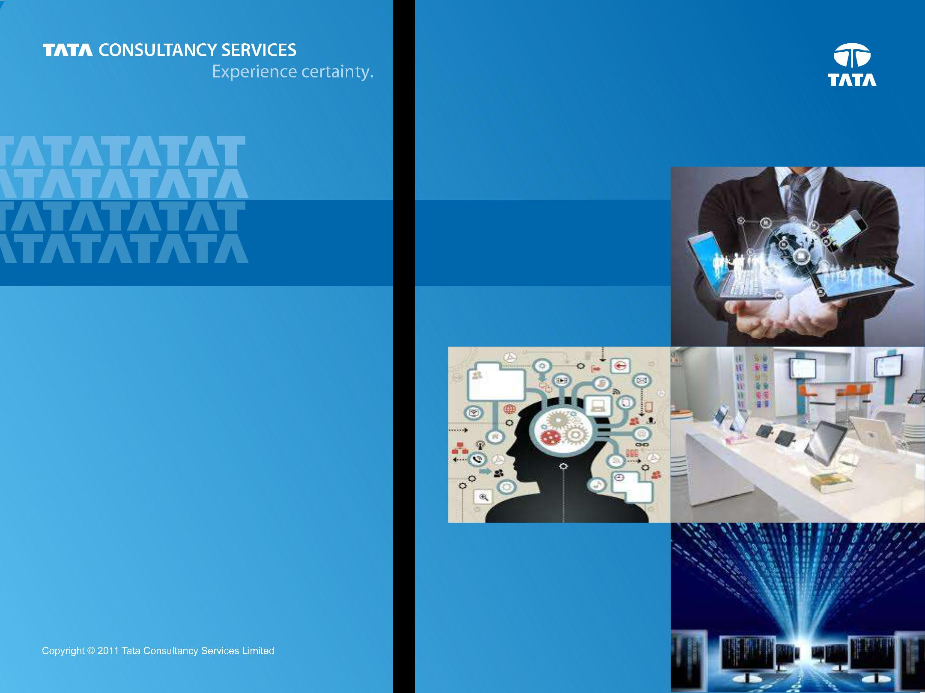

***Bank’s view of itself***

***Customer’s View of Bank***

**Digital Banking**

***Chapter 2 : Customer***

**Prepared : October, 2014**

1

**Content**

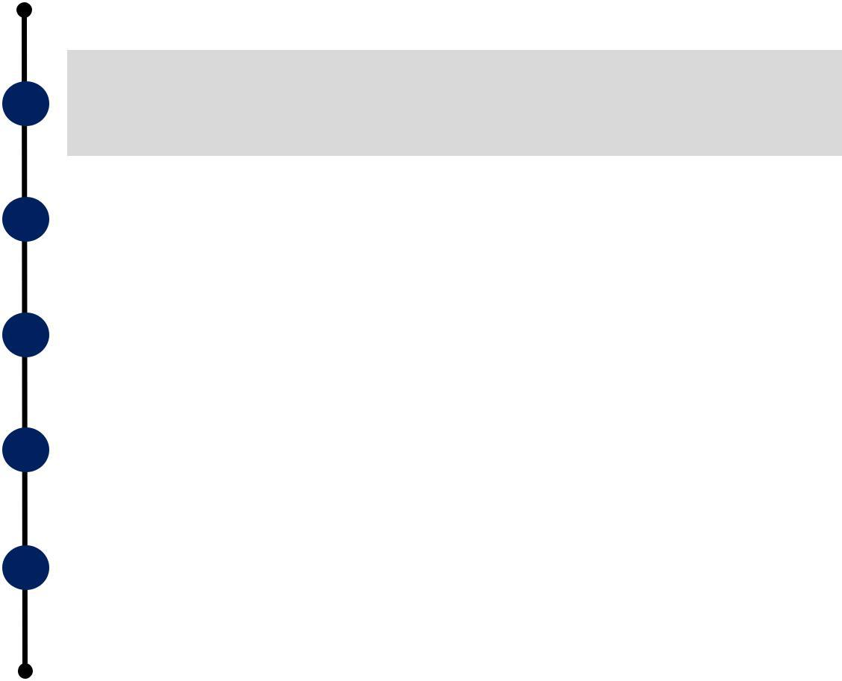

**Introduction**



**Customer**



**Banking Digitally**



**Channel Transformation**



**Effects on Retail LoBs**



2



**Customer Context**

|  |  |  |  |  |  |
| --- | --- | --- | --- | --- | --- |
|  |  |  |  |  |  |
| **Who you are** | | | **Where are you** | **What are you doing** | **What are you likely do** |
| **“Next”** |
|  |  |  |  |  |
|  |  |  |  |  |  |



**Social KYC**

Usage of Social media circles information for KYC



**On the Playground**

Wi-Fi for replays, Pre Order food with preferences, nearby utilities, Socialize thru

“Highlight” : all for NFL

Patriots fans

**Listening & Geo Fencing**

Vintank platform analyzes conversations, creates Klout like scores enabling pin point marketing for geo fenced wineries



**On the ‘Way’**

Interesting mobile apps like: Glympse, Twist and Waze creating new possibilities

**Shopperception**

3D sensor on roof of stores to understand what is being touched, stood at, put into cart -> demand, behavior, loyalty/offers



**Context Transference**

Information across Channels, Capability / Experience across Devices

***Phenomena (Mobile, Social, Analytics, Location, Sensors)*** *➔* ***Contextual Computing with Data as the Oxygen***



| Reebok store on Manhattan 5th avenue uses Cara (sensor based camera) | 3 |
| --- | --- |
| that can understand age, gender, mood from 25 feet away. |  |



**Customer Personas**

|  | ***Demographic*** | ***Psychographic*** |
| --- | --- | --- |
|  |
|  | A – Digital Savvy | D – Value |
|  | B – Income | E – Loyalty |
|  | C – Proximity *(5= Near)* | F – Experience |

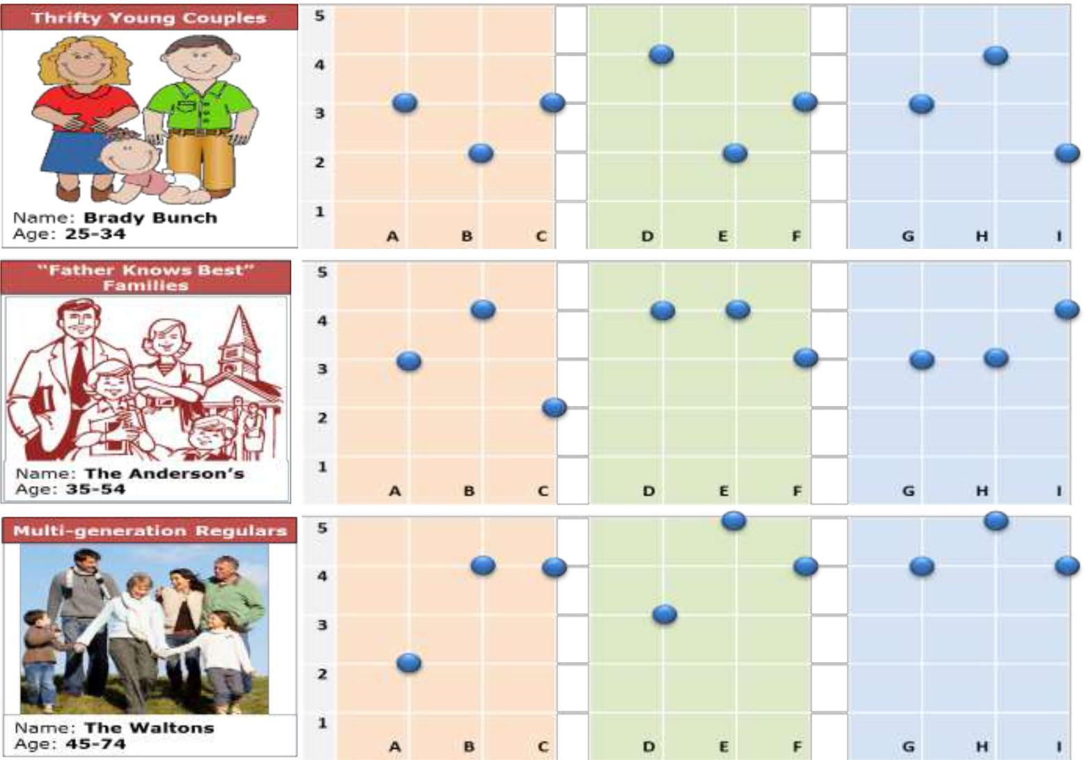

**Persona Priorities:**



* **Value**
* **Experience**
* **Service**



**Persona Priorities:**

* **Community**
* **Tradition**
* **Experience**



**Persona Priorities:**

* **Memories**
* **Comfort**
* **Consistency**

***Behavior***

| G – Shopping, Dining & Lodging |  |
| --- | --- |
| H – Frequency |  |
| I – Spend-ability | 4 |

**Customer Experience 1.0**

***This is what we saw at the beginning of the Digital era as things as the anatomy of customer experience from customer facing and enabling capabilities standpoint***

***What a***



***Customer Sees***

***or Feels ?***

**[Functional]**

| Single View of |  | eCommunications |  | Status / Alerts |  | Customer Care |
| --- | --- | --- | --- | --- | --- | --- |
| Customer |  |  |  |
|  |  |  |  |  |  |
|  |  |  |  |  |  |  |

| Cross Channel |  | Treatment |  | Cross Sell / Up Sell |
| --- | --- | --- | --- | --- |
| Consistency |  | Personalization |  |
|  |  |  |
|  |  |  |  |  |



***What makes it happen ?***

**[Foundational]**



Customer Profile /

Customer Analytics Case Management

Preferences



| Workflow |  | Knowledge |  | Document |  | Contact History |
| --- | --- | --- | --- | --- | --- | --- |
|  | Management |  | Management |  |
|  |  |  |  |  |
|  |  |  |  |  |  |  |



5



**Customer Experience 2.0**

***… and this is how the imperatives transformed with the advent of ‘interplay’ of Digital forces***

***What a End or End Customer Sees or Feels ?***

**[Functional]**

***What makes it happen ?***

**[Foundational]**



|  | Hyper | | |  |  |  |  | Digital Money | |  |  |  | Experience | | |  |  | “Gamified” | |
| --- | --- | --- | --- | --- | --- | --- | --- | --- | --- | --- | --- | --- | --- | --- | --- | --- | --- | --- | --- |
|  | personalization | | |  |  |  |  |  |  |  | Continuity across | | |  |  |
|  |  |  |  |  | Management | |  |  |  |  |  | Engagement | |
|  | (Context, Dynamic Pricing) | | |  |  |  |  |  |  |  | Channels | | |  |  |
|  |  |  |  |  |  |  |  |  |  |  |  |  |  |
|  |  |  |  |  |  |  |  |  |  |  |  |  |  |  |  |  |  |  |  |
|  |  |  |  |  |  |  |  |  |  |  |  |  |  |  | |  |  |  |  |
|  |  | Social Banking | | | | |  |  |  | Payment | | | |  |  | Adaptive Advisory | | |  |
|  |  |  |  | Metamorphosis | | | | |  |  |  |
|  |  |  |  |  |  |  |  |  |  |  |  |  |  |  |
|  |  |  |  |  |  |  |  |  |  |  |  |  |  |  |  |  |  |  |  |
|  |  |  |  |  |  |  |  |  |  |  |  |  | |  | |  |  |  |  |
|  |  |  |  |  |  |  |  |  |  |  |  | API | |  |  |  |  |  |  |
|  |  | Comprehensive | | | | |  |  | (Internal, Open) | | | | |  |  |  | In memory real | |  |
|  |  |  |  |  |  |  |  |  |  |  |  |  |
|  |  | Customer 360 | | | | |  |  |  |  |  |  |  |  |  |  | time Analytics | |  |
|  |  |  |  | |  |  |  |  |  |  |  |  |  |  |  |  |  |  |  |
|  |  |  |  |  |  |  |  |  |  |  |  |  |  |  |  |  |  |  |  |
|  | Cloud Based | |  | |  |  | NextGen Channel | | |  |  |  | Banking Platform | | |  |  | Ecosystem Play | |
|  | Utilities | |  |  |  |  |  |  |  |  |  | with non banking | |
|  |  | |  |  |  | Architecture | |  |  |  | Modernization | | |  |  |
|  | (Doc, Image mgmt) | |  |  |  |  |  |  |  |  |  |  | entities | |
|  |  | |  |  |  |  |  |  |  |  |  |  |  |  |  |
|  |  |  |  |  |  |  |  |  |  |  |  |  |  |  |  |  |  |  |  |
|  |  |  |  |  |  |  |  |  |  |  |  |  |  |  |  | 6 | | | |



**Customer 360 Panorama**

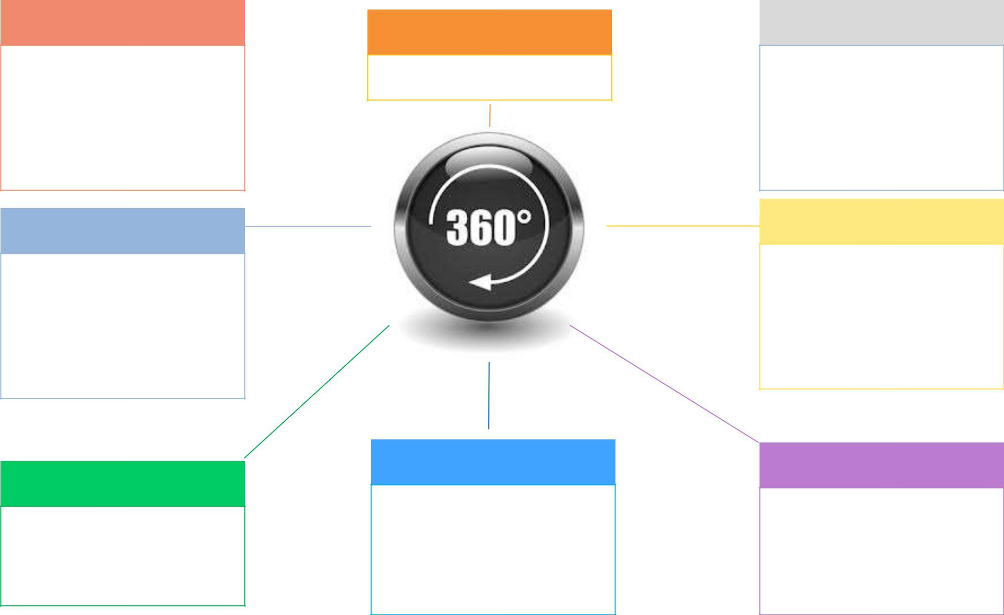

| ***Risk Profiling*** | ***Customer Identity*** |
| --- | --- |
|  |

***Relationship Visioning***

Behavioral profiling (Customer, Segment, Industry) ; Use of alternate data sources and Comprehensive Credit Reports to asses risk, Life Style assessment based on transaction, spending habits

***Social Activity***

Social Influence, Activity versus Outcome, # of Friends & Followers, Average posts per week, trending sentiments by topic

***Interaction Linkage***

Latest interactions across Channels (reasons, products, emotions, preferred channel)



Have a handle on social handles and enterprise IDs

***Context Awareness***

Recent Locations, Life Events, CLTV (expected, actual), visit recency & frequency, top pages by visit count / dwell time / exit pages / liked

***1 - Sale types could be: Regular, Promotion or Rebate driven, Price Match, Cross sell, Bundle***

Visioning of Bank’s relationship with the customer, Projecting life time value of Bank’s relationship to customer

***Purchase Behavior1***

Product holdings, txns (value, volume, frequency, category, channel), spend instrument, anchor brand & category, order summary with timeline

***Demographics***

Education, Friends & family (customer, prospects), Nationality, Religion, Ethnicity, nearest branch/ATM, Hobbies & Interests

7

**Effortless Experience : A CEB View**

|  |  |  | ***Customer Experience Bloopers*** | |  |
| --- | --- | --- | --- | --- | --- |
|  |  |  |  |
|  | | |  |  |  |
| **Exceeding Focus on** | | | **65 % Perception and 35 %** | **Mismatched perception** | **Delinked Loyalty and** |
| **exceeding expectations** | | | **Actual Effort** | **on FCR** | **Customer Satisfaction** |
|  |  |  |  |  |  |



***Loyalty = Re Purchase + Increased Spend + (Unstimulated / Non Gamified ) Brand Advocacy***



***Key***



**Customer Effort Score** is1.8 times more effective than Customer Experience



Focus on **Guided** **Resolution** rather thanproviding more choices

**Minimize call backs** bysolving the Next problem and not just the Current one



***Imperatives***



**Engineer Experience** to reduce customer’s perceived effort :positive language, advocacy, conversation style suited to customer personality and alternatives focused on what can be done

Focus on **Knowledge** **worker** with judgments,not scripts

***Note:***

***1. Hardly much of a difference in CSR across the Big 4 in ANZ region ; Business Banking customers not so happy.***

1. ***CSR high for building societies, credit unions, regionals, offshore banks - due to better interest rates in loans, deposits and fees***
2. ***High value customers are less satisfied needing more personalized attention.***



8



**Next Chapter : 3**



**Introduction**



**Customer**



**Banking Digitally**



**Channel Transformation**



**Effects on Retail LoBs**



9



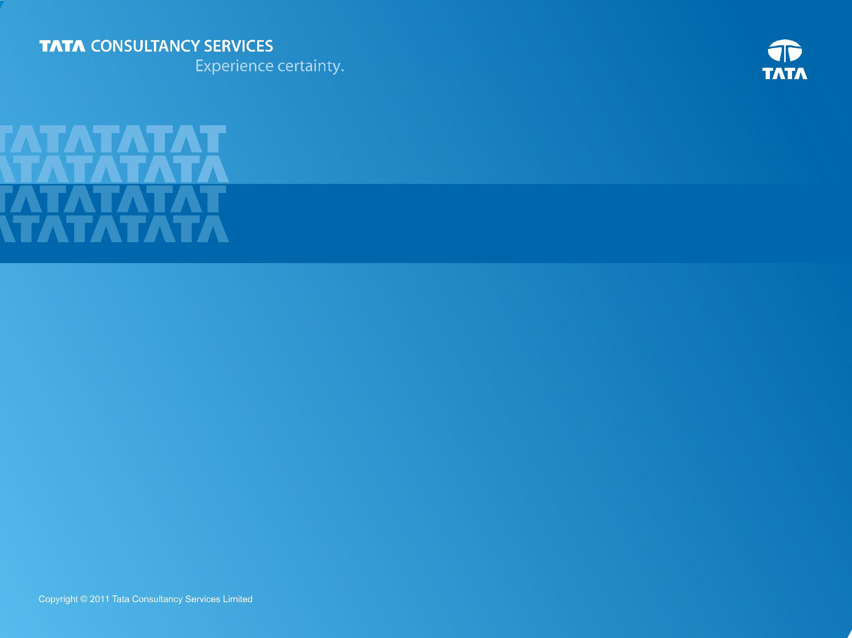

**THANK YOU**

**Prepared : October, 2014**

10